

Honours Year Computer Science Project Proposal

**Robot navigation in logistics/warehouse environments**

Henry Ibeneme (ID: 201458685)

**Contents**

Project description 2

Aims and objectives 3

Key literature 3

Development & implementation summary 4

Data Sources 4

Ethical considerations 5

BCS project criteria 5

UI/UX Mock-up 5

Project plan 6

Risks & Contingencies 6

References 7

**Project description**

Over the last couple of years, we have seen unprecedented growth in robotics. So much so that robots have become ubiquitous in almost every aspect of human life and provide many practical applications. This has coincided with the growing idea of “Industry 4.0” also referred to as The Fourth Industrial Revolution. Although still in the early adoption phases the potential benefits of robotics in E-commerce and logistics specifically are apparent. The level of demand the major companies face these days puts enormous pressure on the logistics services and the people who work there, some of the common problems caused by this include unreliability (low retention rates in warehouses/logistics careers), cost inefficiency (productivity to wage ratio) and typically poor and inconsistent routing strategies. There is also the fact that humans are not ‘rational’ therefore there is a risk of theft and vandalism. All these factors result in consistent losses in revenue and therefore lost profits.

However, with the technology now available we begin to wonder what can be achieved when we bring multiple “intelligent agents” together and by applying laws from fields such as economics, mathematics and even psychology we start to understand how robots can cooperate, coordinate, and communicate with one another.

Thus, this project presents a system designed for a set of autonomous vehicles in an indoor environment to cooperate on a shared task. The task would involve actions like visiting a set of known locations provided by a map with references to objects on this map; the known locations must also be visited in a strict order. The system should allow for collision avoidance, re-routing, pausing and variable travel speed as well as being characterised by lightweight computational algorithms for localization and navigation. The project can be broken down into three main problems:

* Path planning, where I will explore the commonly known multi-agent pathfinding problem (MAPF), consisting of motion-planning a collision free path for a group of agents between their start and target locations [1].
* Sequencing and delivery, where I will explore the multi-agent package and delivery problem (MAPD), here the key goal is to maximise system efficiency [2].
* Effective warehouse design, where I explore the layout and system in the environment affects how I approach the problem.

Each major component of the system will have a simulated testing scenario to evaluate the full capabilities of the design. The system developed must be efficient from a computational standpoint and scalable both vertically and horizontally.

**Aims and objectives**

**Aims**

* Produce a simulation that depicts the ideas of a multi-agent system in a logistics/warehouse environment.
* Explore and assess how mobile robots can work together to achieve a shared task
* Evaluate effective solutions for the multi-agent pathfinding problem (MAPF).
* Evaluate effective solutions for the multi-agent package and delivery problem (MAPD).
* Evaluate effective solutions for efficient warehouse design.
* The Solutions produced should be reproducible and scalable

**Objectives**

* There should exist a simulated logistics environment that all the mobile robots exist in and can interact with.
* There should exist a second logistics environment with an alternative configuration to the first where one is a test environment and the other is a deployment environment for scalability testing.
* Within a simulated world, there should be a set of known locations
* Regarding the known locations, there should be a strict order that they should be visited. This is the shared task of the mobile robots.
* The robots must be able to manoeuvre and complete the task without collisions
* The robots should have the ability and intuition to travel at different speeds
* The robots should have the ability and intuition to pause indefinitely
* The robots should have the ability and intuition to re-plan their route if one breaks down.
* Create an independent unit responsible for localisation.
* Implement “Social laws” to create desired emergent behaviour

# **Key literature**

My key literature reading started with me looking deeper into the problem I was trying to address from a Real-world perspective.

First, we must discuss the benefits of robots for business. Firstly, and probably most importantly is the cost reduction of labour and the productivity boost it provides. An example of such is A Japanese retailer Uniqlo who run an automated warehouse with 90% of its workers replaced by warehouse robots with these robots being able to work near enough 24 hours a day [3].

From here I began to explore the technical Issues that I would have to tackle, in doing so I discovered the 3 Problems, I mentioned in the project description. The broad problem is one of Cooperative Distributed Problem Solving (CDPS), This is the study of how a loosely coupled network of problem solvers can work together to solve problems beyond their individual capabilities [4]. This text discussed this problem in a broader context than my application, ranging from distributed planning and control to computer-supported systems; however I was able to gain a deeper understanding of the problem I was tackling. Allowing me to break down CDPS into three main aspects, namely Problem decomposition which tackles how you can divide the problem into smaller tasks; Sub-problem solution which has to do with optimising problem-solving activities of agents to produce a solution that maximises some coherence metric; and lastly Answer synthesis which has to do with synthesising an overall solution from the solutions of the subproblems.

Now that I was aware of the problem in more technical terms, I had to pick an implementation style for my solution, I decided on using the idea of social norms and the emergent behaviour from these social norms/conventions. Conventions play a key role in the social process; they provide agents with a template upon which to structure their action repertoire. They represent a behavioural constraint, striking a balance between individual freedom on the one hand, and the goal of the agent society on the other. As such, they also simplify an agent’s decision-making process, by dictating courses of action to be followed in certain situations [5]. The paper goes on to model and evaluate the differences between an emergent approach and an offline approach highlighting that although the former is more complex to implement it is much better equipped to deal with changing goals (which often occur in logistics environments). This was my final justification for selecting this approach.

From this point on the rest of my literature reading had to do with the tools I was going to use and the best practices concerning them, this is covered in the development & implementation summary.

# **Development & implementation summary**

**The Development environment**

All the development will be done within the Webots simulation environment. This is a professional mobile robot simulation software package that offers a rapid prototyping environment and allows for the creation of 3D virtual worlds with accurate Physics properties.

I have chosen the Webots simulator as it is the industry standard for Autonomous Robotics simulators. Compared to competitor software such as V-REP and Gazebo it has been found that Webots provides the best balance in terms of computational performance vs resource usage as stated in this research article “In general terms, our results show that Webots is the simulator with the lowest use of resources, followed by V-REP, which has advantages over Gazebo, mainly because of the CPU use” [6]. Webots has a few language options when it comes to programming controllers and my language of choice for this project will be python. I made this choice to speed up the development and testing phases of the project as it is a language I am more familiar with as well as being an interpreted language rather than a compiled one.

**Implementation**

The project will be initialised with Git as it is a great tool for version control that I have experience with. The project will be loosely split into 2 phases, firstly creating a naïve system without “social policies”. The second phase would be my actual implementation of an efficient multi-agent system which will then be compared with the naïve approach. From this, I will then use the Webots animation functionality to produce a video depiction of both project parts.

The project hinges on an efficient implementation and evaluation of a distributed path-finding algorithm that can plan trajectories while simultaneously avoiding collisions like the **WHCA\*** and **CRPA\*** algorithms [7].

The implementation process will follow an agile methodology due to the nature of development in robotics and the level of dependencies involved. In doing this I aim to begin with a naïve approach to the problem and iteratively Improve the approach and its components until I come to the desired result, rather than working on the components in isolation. Using an agile approach will allow me to develop a multi-agent system quickly and efficiently, thus improving project performance [8]. To aid this I will be using Jira as a tool to break down and track the development progress.

# Data Sources

My project uses no human data.

# Testing and evaluation

The Project will be tested and evaluated using a variety of approaches to ensure both functional and non-functional requirements are met. Due to the nature of the project, my focus will be on functional testing to evaluate performance and to make sure all the functional elements specified are achieved. This approach simulates real-world usage and is effective at finding functional errors. However, there is also the possibility of omitting logical mistakes and this doesn’t catch performance issues. The main form of functional testing to be used will be Acceptance testing. Therefore, to supplement this I will also be performing performance tests which is a non-functional technique used to determine how an application will behave under various conditions [9]. The aims and objectives will form the basis of the requirements.

# Ethical considerations

This project will remain ethical throughout its duration and will strictly obey the University of Liverpool's ethical guidelines. There are no participants so things like consent and age checking will not be required, this also means there is no risk of exposure to sensitive topics.

My project will likely use some public domain data such as external environment assets and algorithms so where necessary I will obtain proper licensing terms and make sure anything I use aligns with fair use policies.

I will not be collecting any personal information and I will not be sharing any personal information so combining all these facts I believe my project aligns with the Data Protection Act 2018 [10] and I have considered all ethical issues possible.

# BCS project criteria

This project allows me to apply a vast array of practical and analytical skills I have gained throughout my degree programme. The knowledge I have gained during my autonomous mobile robotics is vital to the development of this project seeing as the project explores ideas within multi-agent systems. Previous work like the second-year group project has also equipped me with knowledge about the software development process, Time management and self-evaluation skills. These ideas and practices have allowed me to propose a quality solution to my posed problem and the ability to critically evaluate the solution.

Moreover, this project is innovative as it could lead to a new operating/business model for major companies where efficient multi-agent systems replace human labour. It would also require new technology to make such systems computationally cost-efficient to implement on a large scale further emphasising the innovative nature of such a proposal. Innovation also has to do with developing and optimising well-known methodologies and because the field of robotics and multi-agent systems is thoroughly researched a lot of this project will entail taking these methodologies and applying or developing them in unique ways.

My first action regarding the project was to spend time collating and synthesising all information that could aid the development of the project, that was when I was able to produce a detailed Timeline via the Gantt chart in the project plan section, I also decided on using Jira tickets to track my progress and allow me to evaluate continuously with smaller milestones.

This project pertains to a real need in a wider context as corporations are very much driven by profit and revenue therefore with a successful version of my project, I will be displaying how companies can improve efficiency and minimise losses in warehouse/logistics environments using multi-agent systems in robotics.

As mentioned earlier tasks will be broken down into smaller modules of work doing so will then allow me to set personal deadlines allowing me to evaluate my ability to complete tasks as well my approach to the solutions. From this, I can generate self-collected performance results that will also be used in the evaluation process.

# UI/UX Mock-up

Because Effective environment design is a major part of the project implementation, I cannot provide a definitive representation of what the environment would look like but here are some examples of the structure for the 2-D and 3-D representations of the environment. It is likely the actual deployment environment would look a lot more polished than this. The final product will be a recording of the simulation in action.

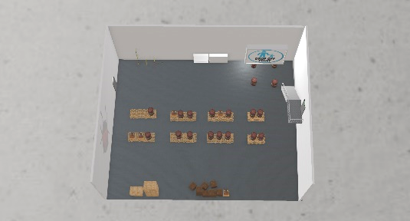

# Project Plan

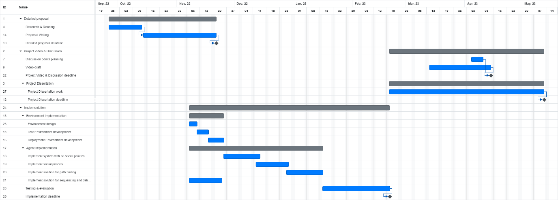

This Gantt Chart Provides a broad overview for the timeline of my project however there is likely to be more overlap than this and shifts in schedule as I have learnt is often the case during software development of any kind. To be prepared for such actualities I intend to create a Jira board to break down and closely track progress of individual tasks.

I also appreciate that testing is a continuous process so although I have an allocated extensive testing period, I will be testing and evaluating throughout the timeline of the of project.

# Risks & Contingencies

| **Risk** | **Contingencies** | **Likelihood** | **Impact** |
| --- | --- | --- | --- |
| With such computationally intensive technology, there is a risk of software failure | Consistent Backups to aid recovery | Low | medium - Crashes in Simulation resulting in loss of progress |
| Hardware failures such as dead hard drives/SSD | Secondary backups on a separate device like an external drive | low | High - Without proper contingencies this could have a high impact on the project such as permanent loss of data/progress |
| Systematic errors in code that lead to unexpected/undesired behaviour | Proper planning and code implementation should help combat this. | Medium | Medium - Poor final product with inaccuracies in simulation. |
| Running out of time (all objectives at the end of the project not achieved) | Thorough plan with smaller milestones to allow for adjustments to be made during development. | Low | High - Incomplete project with missing features, entire program not working altogether, missing documentation sections. |
| Programming problems | There is a vast amount of documentation regarding python and Webots so problems can be solved with enough work. | Medium | Low – Most programming issues can be solved or worked around given enough research. |
| Schedule Limitations – unexpected changes to my schedule that could affect the project timeline. | Consistent revaluation of the project plan and updating the timeline. | Medium | Low |

# References

| [1] | A. B. Ko-Hsin Cindy Wang, “Fast and Memory-Efficient Multi-Agent Pathfinding,” in *ICAPS*, 2008, pp. 380--387. |
| --- | --- |
| [2] | M. a. N. P. a. K. A. a. S. M. Čáp, “Prioritized Planning Algorithms for Trajectory Coordination of Multiple Mobile Robots,” *IEEE Transactions on Automation Science and Engineering,* vol. 12, no. 3, pp. 835-849, 2015. |
| [3] | Innovecs, “Innovecs,” 2018. [Online]. Available: https://innovecs.com/blog/amazon-alibaba-ocado-use-warehouse-robots/. [Accessed 15 October 2021]. |
| [4] | E. H. Durfee, “Trends in Cooperative Distributed Problem Solving,” IEEE , Michigan, 1989. |
| [5] | M. W. Adam walker, “Understanding the Emergence of Conventions,” Department of Computing, Manchester Metropolitan University, Manchester, 1995. |
| [6] | F. C. D. C. R. R. B. f. R. D. Angel Ayala, “A Comparison of Humanoid Robot Simulators: A Quantitative Approach,” ICDL-EpiRob, 2020. |
| [7] | N. a. B. M. Sturtevant, “Improving Collaborative Pathfinding Using Map Abstraction,” in *Proceedings of the Second AAAI Conference on Artificial Intelligence and Interactive Digital Entertainment*, California, AAAI Press, 2006, p. 80–85. |
| [8] | D. A. D. a. X. R. a. B. C. a. E. P. a. V. R. a. C. Y. a. L. C. Vargas, “Implementing SCRUM to develop a connected robot,” *arXiv preprint arXiv:1807.01662,* 2018. |
| [9] | SMARTBEAR, “smartbear.com,” [Online]. Available: https://smartbear.com/learn/automated-testing/software-testing-methodologies/. [Accessed 22 10 2022]. |
| [10] | UK legislation , “legislation.gov.uk,” 25 may 2018. [Online]. Available: https://www.legislation.gov.uk/ukpga/2018/12/contents/enacted. [Accessed 1 11 2022]. |